IT 204

Signals & Systems

Project Report

Information Technology

National Institute of Technology

Karnataka Surathkal,

India 575025

Kartik Nagesh Pauskar Akshay Sreekumar Nair

191IT223 191IT103

Email - [kartikpauskar.191it223@nitk.edu.in](mailto:kartikpauskar.191it223@nitk.edu.in) Email - [a.191it103@nitk.edu.in](mailto:a.191it103@nitk.edu.in)

Shashikant Kumar Shiv Kumar Dubey

191IT249 191IT250

Email - [shashikantkumar.191it249@nitk.edu.in](mailto:shashikantkumar.191it249@nitk.edu.in) Email - [shiv.191it250@nitk.edu.in](mailto:shiv.191it250@nitk.edu.in)

Automated Car Parking System

**Abstract**

This research proposes an automatic parking system for busy urban areas. This project includes sensor information fusion, position estimation, path planning, and tracking algorithm. First we have a **Car-Detection** algorithm which as the name suggests detects whether a car has arrived at the parking gate and feeds it to the server room. Then we have LED Displays at the gate which will display the available parking slots at the area. If there are unoccupied slots available then the **Searching Algorithm** comes into place, which will look for those empty parking slots with the help of the **Ultrasonic Sensors** at the base of the parking slots. Once this is done the system also searches for the Shortest Distance to the slot, which indeed saves time and this is done with **Shortest Distance** algorithm. Once the data is fetched, we have Strips on the ground which will turn black specifically to guide the car to its parking slot. This is achieved by placing an **IR (Infra-red)** **Sensor** at the bottom of the cars. Finally the data at the server will be updated and the Bill is Generated.

**Introduction**

Automatic parking is one of the growing topics that aim to enhance the comfort and safety of driving. It can help drivers automatically drive the car in constrained environments where much attention and experience is required. The parking strategy is completed taking into account the actual situation in the environment to ensure collision-free motion within the available space.

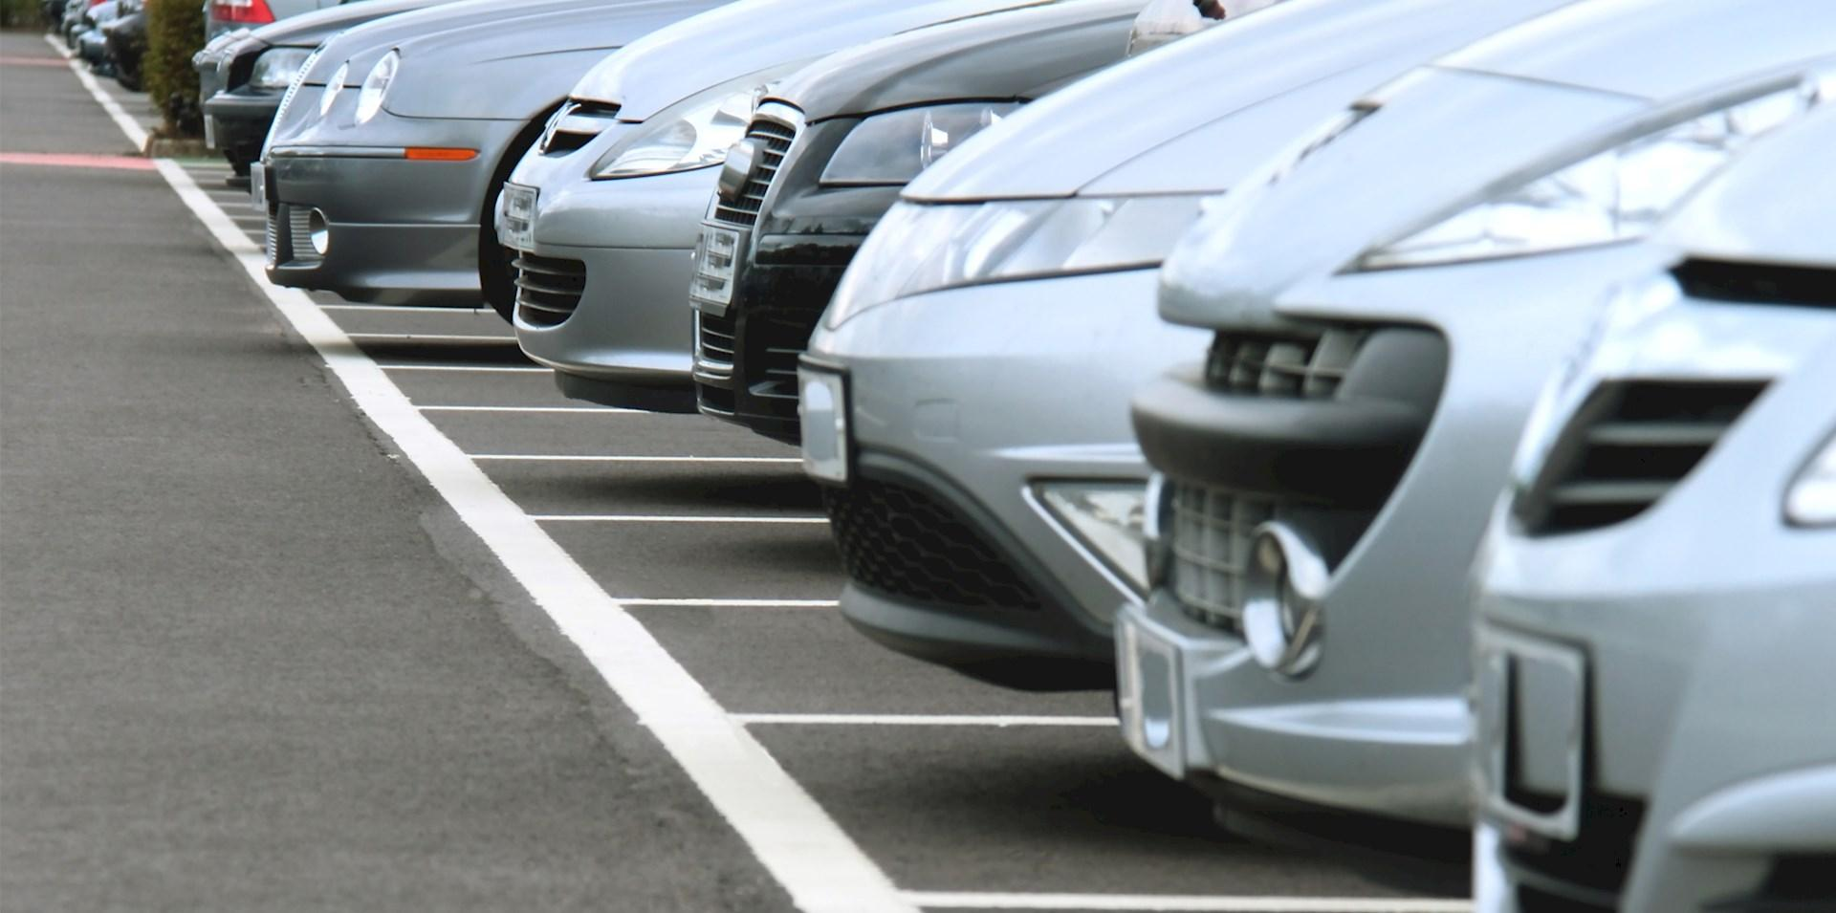

Over the decades, our country has developed drastically, now we are in this state that we have a lot of well contacted roads, commercial buildings and increasing numbers of automobiles. While parking these automobiles in parking space we use the manual procedure of parking which in most cases are unplanned ;lack of discipline due to this, people park their cars anywhere they want to, which creates a mess as people do not follow the particular cue most of the time. As a result of this, a huge traffic jam takes place in that place. While parking in and retrieving cars due mismanagement may cause accidents. This leads to arguments, fights among people which sometimes eventually leads to traffic overtime. This issue also leads to economic loss, namely damaged cars, extra fuel consumption,etc. Traffic jams are an issue here as it kills our precious time. Due to this chaos in parking our valuable time gets wasted. It harms the students, office going staff and emergency patients to a great extent.

The main problems faced in the Urban areas regarding parking are:

* Inefficient Time management.
* Traffic Chaos.
* Accidents by amateur drivers and many more….

**Key Contributions -**

* **Reducing traffic jam:** Automated vehicle systems help reduce the traffic by efficiently parking vehicles avoiding inappropriate parking.
* **Time saving:** In a manual parking system it is difficult to find out the empty space for parking, which is very much time consuming. Whereas here the data of the parking slots is maintained properly,
* **Safety**: Avoids accidents.
* **Fuel saving:** As there is no need to search for an empty slot, there will be no wastage of fuel.
* **Operating cost saving:** There is reduction in the man-hour required as the system does not require any human interaction for the money transaction

**Problems with the Traditional car parking system -**

* We see in many shopping malls, hospitals huge traffic jams in front of the parking.
* It is difficult and time consuming to find out the parking slot which costs extra fuel and wastes time.
* Security is one of the major problems in traditional car parking, resulting in car robberies and many more.
* In manual parking system guards need to be appointed which isn’t cost efficient.

**Literature Survey**

An **Automated parking system** increases the number of cars that can be parked in a garage. It provides more parking spaces since the cars are well organised parked. If you use an automated parking system, you will need less area of land for building a garage. As said earlier, the chances of vehicles getting damaged due to improper parking are considerably reduced in an automated car parking system. With an automated car parking system, there are no or very minimal chances of the vehicle getting lost. But, this is not the case in traditional parking methods.

**Bass papers -**

* Research on Automatic Parking Systems Based on Parking Scene Recognition SHIDIAN MA, HAOBIN JIANG, MU HAN3 , JU XIE AND CHENXU LI
* Development of an Automatic Parking System for Vehicle

Tsung-hua Hsu, Jing-Fu Liu, Pen-Ning Yu, Wang-Shuan Lee and Jia-Sing Hsu

Automotive Research and Testing Center, Changhua County, Taiwan, R.O.C.

**Problem Statement**

At Present there aren't any highly developed smart car parking systems and the existing ones aren’t efficient enough to solve all these problems. It also causes economic loss to commercial places like shopping malls, amusement parks as people are more likely not to visit these places due to this parking hazard. As we are advancing with time, the manual car parking system in commercial spaces is creating hurdles which are causing wastage of time and some economic losses as well. Therefore we need a solution which can overcome these problems.

**Objectives:**

* To develop an Automated Parking System.
* To contribute to the development of Urban areas.
* To minimise the wastage of time and fuel.
* To ensure public safety in Parking areas.
* To avoid traffic accidents and chaos.
* To reduce man-power.

**Methodology**

As mentioned in the abstract part, The main algorithms developed for this project are as follows:

1. **Car - Detection Algorithm**
2. **Action on Car Detection**
3. **Searching Algorithm**
4. **Finding a Shortest - Path**
5. **Path Tracing**

**Flowchart for the system:**

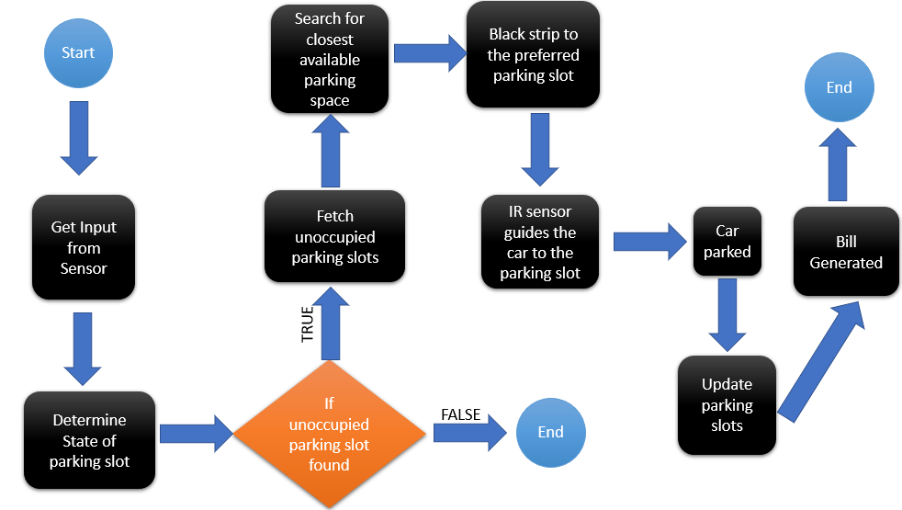

**[A] Car - Detection Algorithm:**

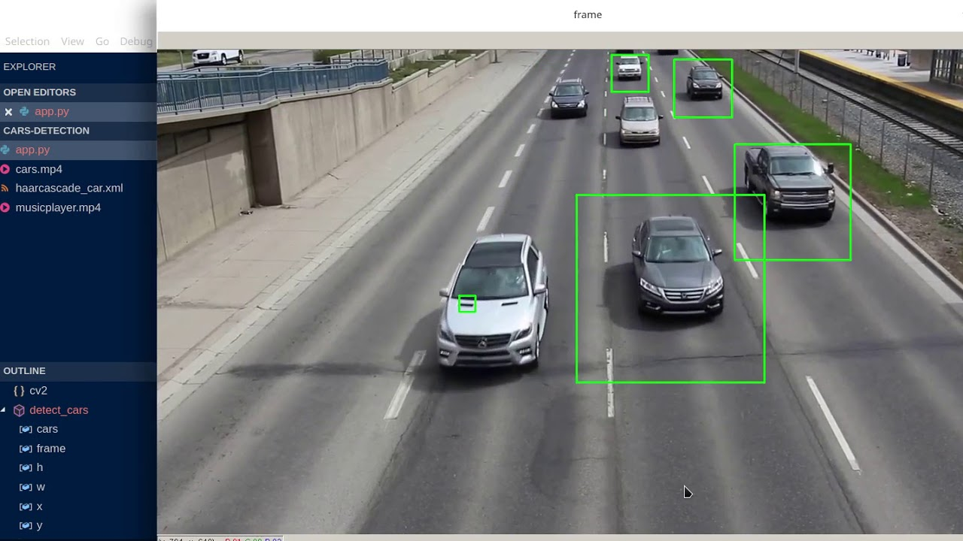

**Car Detection by Image Processing**

Target detection is also called target extraction, and its purpose is to identify the required information from a picture. Target detection specifically refers to retrieving information from input pictures by a specific algorithm and checking whether the input pictures contain the target information. If a retrieval target exists, the target area will be marked. Vehicle detection is a kind of target detection. It is a popular research direction for machine vision and has been widely used for intelligent transportation, intelligent monitoring and military target detection.

**Digital image processing** is the use of a [digital computer](https://en.wikipedia.org/wiki/Digital_computer) to process [digital images](https://en.wikipedia.org/wiki/Digital_image) through an [algorithm](https://en.wikipedia.org/wiki/Algorithm). As a subcategory or field of [digital signal processing](https://en.wikipedia.org/wiki/Digital_signal_processing), digital image processing has many advantages over [analog image processing](https://en.wikipedia.org/wiki/Analog_image_processing). It allows a much wider range of algorithms to be applied to the input data and can avoid problems such as the build-up of [noise](https://en.wikipedia.org/wiki/Noise_(signal_processing)) and [distortion](https://en.wikipedia.org/wiki/Distortion) during processing. Since images are defined over two dimensions (perhaps more) digital image processing may be modeled in the form of [multidimensional systems](https://en.wikipedia.org/wiki/Multidimensional_systems).

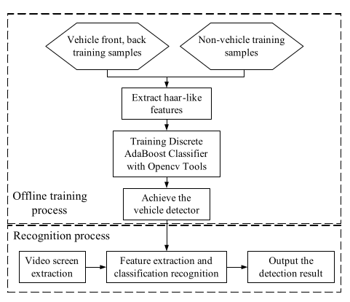

**Flowchart for Car - Detection**

**[B] Action on Car Detection:**

This algorithm is built to fetch that a car has arrived and to take necessary action, i.e. open the gates of the parking area. As soon the **Car - Detection algorithm** returns specific values, (either true or false) that value is saved in a **.txt** file which will be read by this algorithm. As this completes, the **arduino** communicates with the motor which inturn turns it on thus the gates are open. It uses **Servo Motor** for opening the gates.

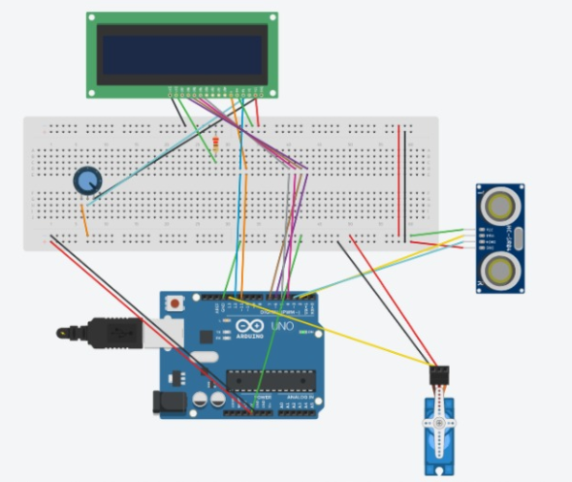

**Tinkercad Simulation of proposed model**

**[C] Searching Algorithm:**

Searching is the process of finding a particular element among several given elements. The search is successful if the required element is found.

Otherwise, the search is unsuccessful.

The two major Searching algorithms used for implementing various things are:

* Linear Search
* Binary Search

And the one we are using is **Linear Search** because it is the simplest searching algorithm. It traverses the array sequentially to locate the required element. It searches for an element by comparing it with each element of the array one by one.

So, it is also called Sequential Search.

**Pseudocode for Searching algorithm -**

Considering,

There is a linear array ‘a’ of size ‘n’.

Linear search algorithm is being used to search an element ‘item’ in this linear array.

If search ends in success, it sets loc to the index of the element otherwise it sets loc to -1.

**Begin**

**for i = 0 to (n - 1) by 1 do**

**if (a[i] = item) then**

**set loc = i**

**Exit**

**endif**

**endfor**

**set loc = -1**

**End**

**[D] Finding a Shortest - Path:**

This algorithm is responsible for finding the shortest distance from the car to the allotted parking slot. And to make this operation more seamless and efficient the distance of all the parking slots has already been fed into the system thus it can allot slots more efficiently saving time.

**Pseudocode for Finding a Shortest - Path -**

**int shortest_distance_slot()**

**for i=0 to 2 by 1 do**

**if(slot_array[i].occu==0)**

**if(slot_array[i].distance<min)**

**set min=slot_array[i].distance**

**set index_min=i+1**

**return index_min**

**[E] Path Tracing:**

Now for the car to automatically park itself at the allotted parking slot, **Path Tracing** comes into place where as mentioned in the abstract part there will be strips on the ground of the parking area which connect the entrance to all the parking slots. As the allotment is done the strip from the entrance to the specific allotted slot turns black and the **IR Sensor** beneath the car detects this color shift and thus guides the car to its specific parking slot.

**Pseudocode for Path Tracing -**

**setup**

**initialize components**

**left sensor output <- digitalRead(left)**

**right sensor output <- digitalRead(right)**

**loop**

**if(digitalRead(left)==1 && digitalRead(right)==1)**

**//move all the motors clockwise**

**else if(digitalRead(left)==0 && !digitalRead(right)==0)**

**//move left side motors clockwise and right side motors anticlockwise**

**else if(!digitalRead(left)==0 && digitalRead(right)==0)**

**//move left side motors anticlockwise and right side motors clockwise**

**else if(digitalRead(left)==0 && digitalRead(right)==0)**

**//stop all the motors**

**Results and Analysis**

This project has been tested by simulations and also hardware implementation. The hardware equipments that are being used here include **Arduino Uno, Ultrasonic sensors, LED’s, Jumper wires, Servo Motor, Motor Shield, IR sensors, etc.**

The IR sensors are being used in the automated car robot as a prototype, can be switched later to **bluetooth** modules or **NavIC/GPS** modules in real-life scenarios.

**Working of Car Detection algorithm -**

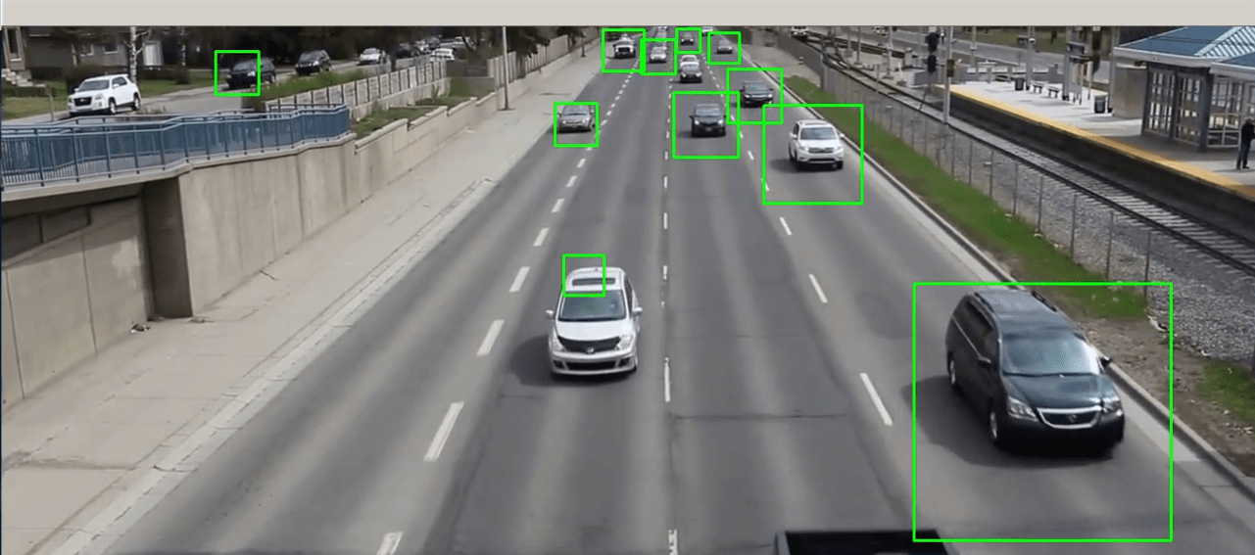

**Designing the Vehicle -**

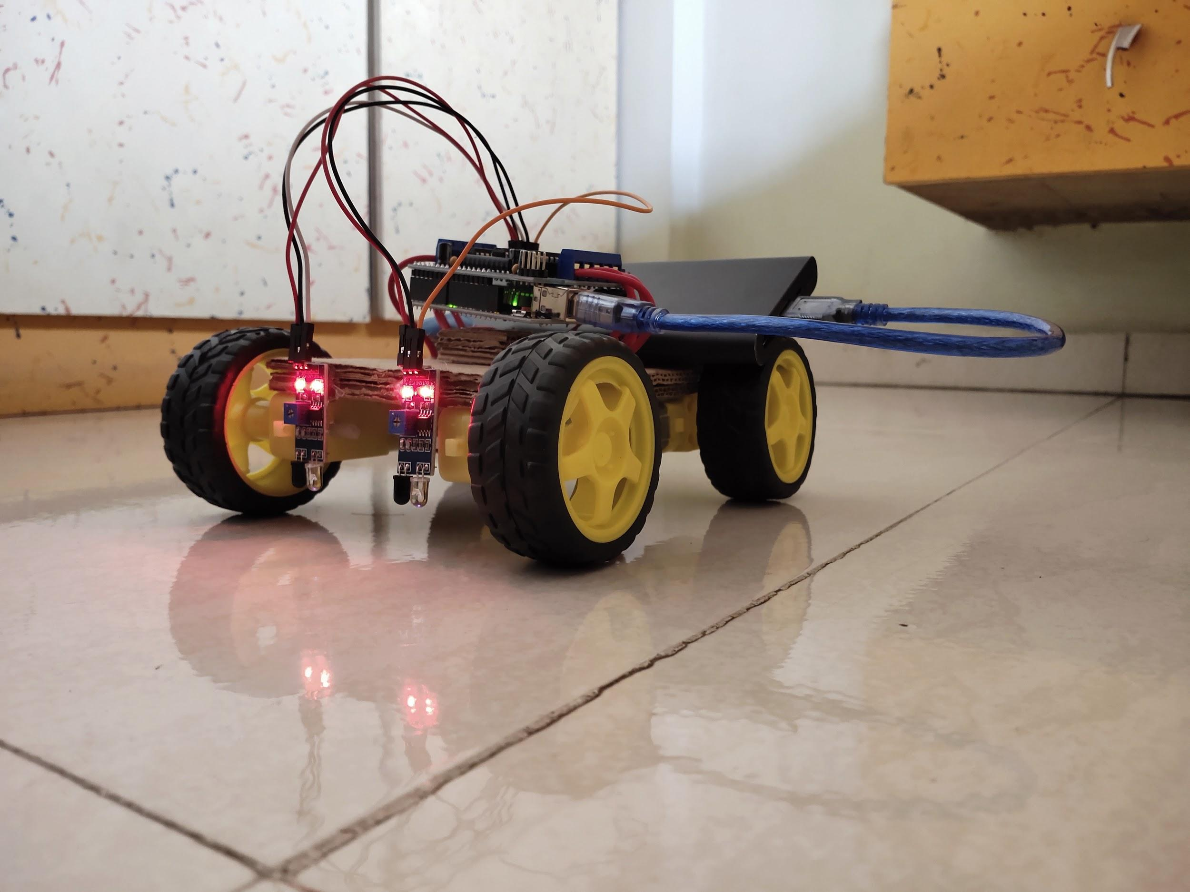

**Integrating the Components -**

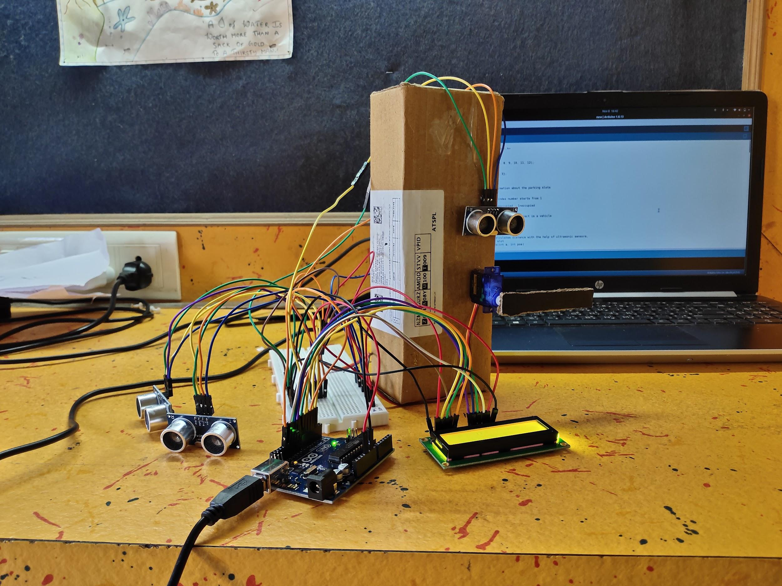

**Prototype for the strips (IR Implementation) -**

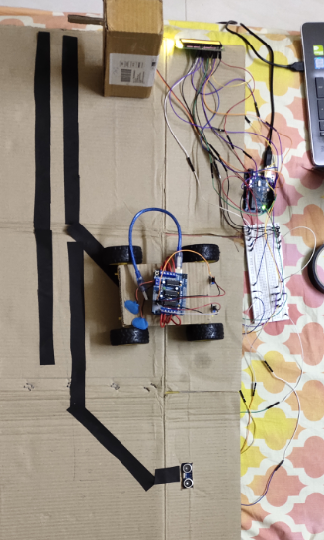

**Conclusion**

Automated car parking can be one of the important resources in traffic areas, multiplexes, apartments, etc; Urban areas where people struggle to park their vehicles due to lack of patience among people and also safety is a major issue in traditional parking areas as discussed earlier it the report, **Automated Parking Systems** are the new future of parking your vehicle.

Also this project solves a lot of such problems such as traffic jams in front of shopping malls, hospitals, etc.It is difficult and time consuming to find out the parking slot which costs extra fuel and wastes time, safety issues like car robberies and many more. In manual parking system guards need to be appointed which isn’t cost efficient.

**Acknowledgment**

A Special Thanks to **Priyadarshini ma’am and GRM sir** for giving valuable opinions and guiding us with this project.

**Individual contribution -**

**Akshay Sreekumar Nair (191IT103) -**

* Basic research
* Learning the concepts
* Code implementation
* Developing model for hardware implementation
* Hardware Integration
* Collection of dataset for Car-Detection
* Searching algorithm
* Path tracing
* Report making

**Kartik Nagesh Pauskar (191IT223) -**

* Basic research
* Learning the concepts
* Design templates
* Code implementation
* Collection of dataset for Car-Detection
* Report making
* LED display implementation
* Action on Detection

**Shashikant Kumar (191IT249) -**

* Basic research
* Learning the concepts
* Code implementation
* Car - Detection algorithm using image processing
* Collection of dataset for Car-Detection
* Shortest-Path algorithm
* Report making

**Shiv Kumar Dubey (191IT250) -**

* Basic research
* Learning the concepts
* Searching algorithm
* Code implementation
* Analysing Code
* LED display implementation
* Report making

**Schedule designed for working -**

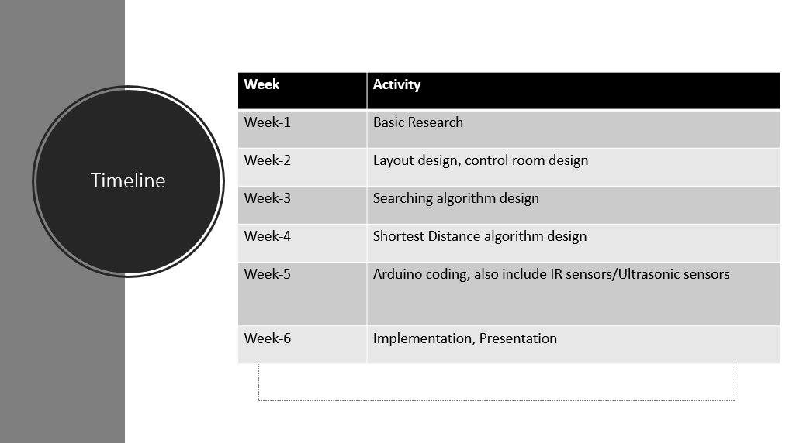

**References:**

1. Research on Automatic Parking Systems Based on Parking Scene Recognition

SHIDIAN MA 1 , HAOBIN JIANG1,2, MU HAN3 , JU XIE2 , AND CHENXU LI2

**Date of Publication:** 18 October 2017

**Publisher:** IEEE

<https://ieeexplore.ieee.org/document/8071146/>

1. Development of an Automatic Parking System for Vehicle

Automotive Research and Testing Center, Changhua County, Taiwan, R.O.C.

**Date of Publication:** 06 May 2020

**Publisher:** IEEE

<https://ieeexplore.ieee.org/document/4677655/>

# Traffic Flow Data Prediction Using Residual Deconvolution Based Deep Generative Network

[Di Zang](https://ieeexplore.ieee.org/author/37085384341); [Yang Fang](https://ieeexplore.ieee.org/author/37086858783); [Zhihua Wei](https://ieeexplore.ieee.org/author/37086859941); [Keshuang Tang](https://ieeexplore.ieee.org/author/37085840234); [Jiujun Cheng](https://ieeexplore.ieee.org/author/37556840100)

**Date of Publication:** 30 May 2019

**Publisher:** IEEE

# [**https://ieeexplore.ieee.org/document/8726377/**](https://ieeexplore.ieee.org/document/8726377/)

1. A Period-Specific Combined Traffic Flow Prediction Based on Travel Speed Clustering

BIN FENG 1 , JIANMIN XU 1 , YONGJIE LIN 1 , (Member, IEEE), AND PENGHAO LI 2

**Date of Publication:** 06 May 2020

**Publisher:** IEEE

1. A Scheme of Intelligent Traffic Light System Based on Distributed Security Architecture of Blockchain Technology

PENGJIE ZENG 1 , XIAOLIANG WANG 1 , (Member, IEEE), HAO LI 1 , FRANK JIANG 2 , AND ROBIN DOSS 2 , (Senior Member, IEEE)

**Date of Publication:** 10 February 2020

**Publisher:** IEEE

1. A Simulation Study of Predicting Real-Time Conflict-Prone Traffic Conditions

Christos Katrakazas , Member, IEEE, Mohammed Quddus, and Wen-Hua Chen, Senior Member, IEEE

**Date of Publication:** 10, OCTOBER 2018

**Publisher:** IEEE

1. Augmenting Traffic Signal Control Systems for Urban Road Networks With Connected Vehicles

Craig B. Rafter , Student Member, IEEE, Bani Anvari, Member, IEEE, Simon Box, and Tom Cherrett

**Date of Publication:** 4, APRIL 2020

**Publisher:** IEEE

1. Intelligent Traffic Management System for Smart Cities -Abhirup Khanna The University of Melbourne Rohit Goyal Himgiri ZEE University Manju Verma Himgiri ZEE University Deepika Joshi Himgiri ZEE University

**Date of Publication:**January 2018

**Publisher:** Researchgate

1. Optimized Public Parking Location Modelling for Green Intelligent Transportation System Using Genetic Algorithms

TONG SHEN 1 , KUN HUA 2 , AND JIAPING LIU 3

**Date of Publication:** 05 December 2019

**Publisher:** IEEE

1. Development of an Automatic Parking System for Vehicle

Tsung-hua Hsu, Jing-Fu Liu, Pen-Ning Yu, Wang-Shuan Lee and Jia-Sing Hsu Automotive Research and Testing Center, Changhua County, Taiwan, R.O.C.

**Publisher:** IEEE

1. Developing Smart Car Parking System Using Wireless Sensor Networks

Aliyu Ahmed Computer Engineering Federal University of Technology Minna, Nigeria aliyu.ahmed@futminna.edu.ng Jonathan Kolo Computer Engineering Federal University of Technology Minna, Nigeria jgkolo@futminna.edu.ng Mikail Olaniyi Computer Engineering Federal University of Technology Minna, Nigeria mikail.olaniyi@futminna.edu.ng Stephven Oyetoro Computer Engineering Federal University of Technology Minna, Nigeria oyetorostephven@gmail.com

**Publisher:** Academia

**Resources:**

1. **Tinkercad** for Simulations - <https://www.tinkercad.com/>
2. **Arduino** for hardware research - <https://www.arduino.cc/>
3. **Hardware** - <https://amazon.in>
4. **IEEE** for Research papers

-<https://ieeexplore.ieee.org/Xplore/home.jsp>

1. **ResearchGate** for Journals

<https://www.researchgate.net/>

1. **Academia** for journals

https://www.academia.edu/

1. **Wikipedia** for definitions**:** <https://en.wikipedia.org/wiki/Digital_image_processing>